Practical - 6
Practical Title: Rendering External JSON Data using Fetch API, Search and Filter
Problem Definition: Display event lists, student profiles, notices, or FAQs from external JSON files using Fetch API. Implement dynamic rendering, search, filter, sorting, and pagination.

Theory

How is JSON fetched, parsed, and rendered?

The JSON data is fetched using the fetch() method from the events.json file. The response.json() method parses the JSON response into JavaScript data. The data is then stored in the events array and rendered dynamically using forEach() and innerHTML.

Which array methods are used for search, filter, sort, and pagination?

The filter() method is used for searching events by title and filtering events by category. The sort() method is used for sorting events by name or date. The slice() method is used for pagination to display a specific number of events on each page.

How are loading and error states handled?

While the JSON data is being loaded, a loading message is displayed. If the fetch request fails or the response is not successful, an error is generated using throw new Error(), and the catch() block displays an error message to the user.

How is modularity maintained in JavaScript files?

Modularity is maintained by keeping the event-related functionality in a separate data.js file. Functions such as displayEvents(), createPagination(), and changePage() handle specific tasks, making the code easier to understand, maintain, and modify.

Reference: MDN – Fetch API

Reference: MDN – Array methods

Result

In this practical I used json (java script object notation) and fetched data using javascript in file and using it to search the objects

Evidence of Work (Screenshots)

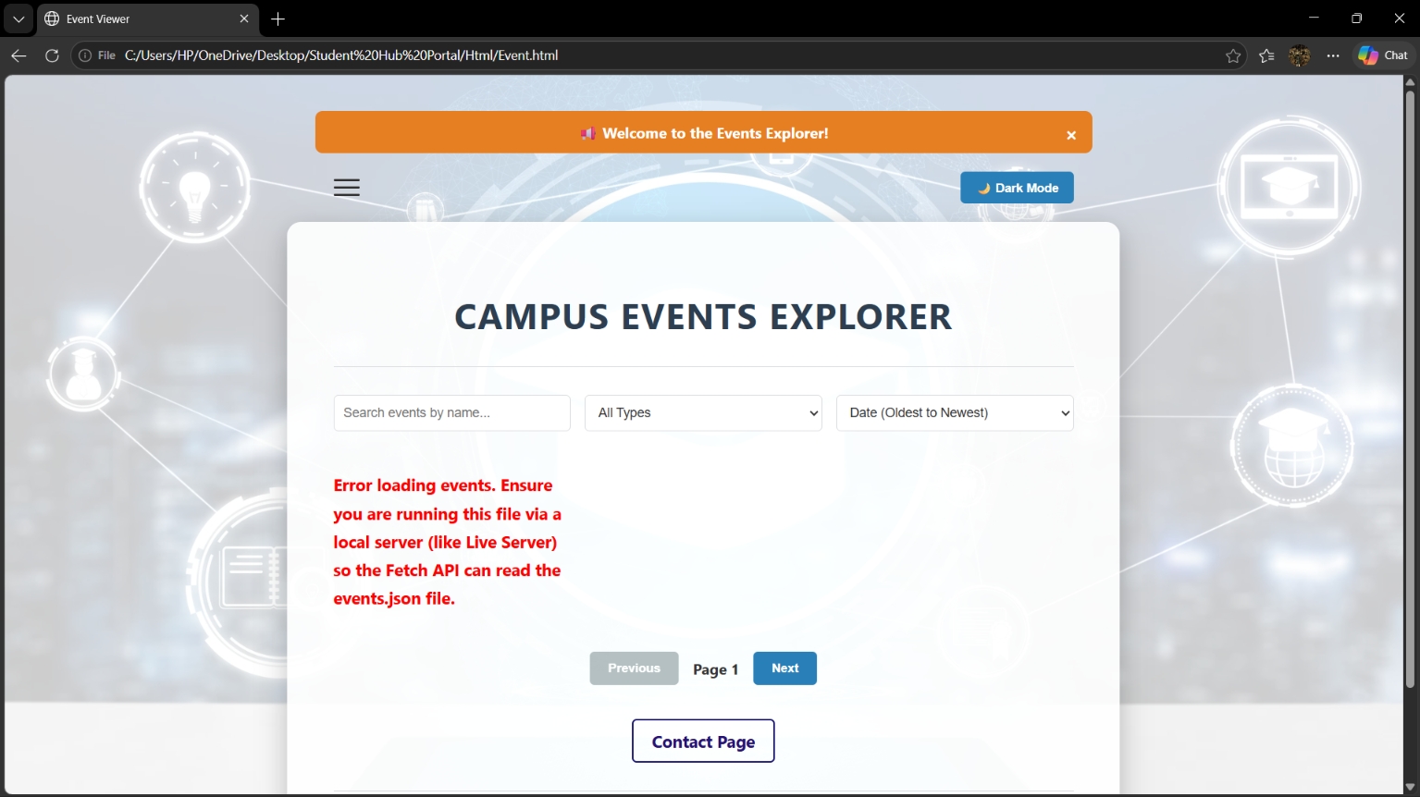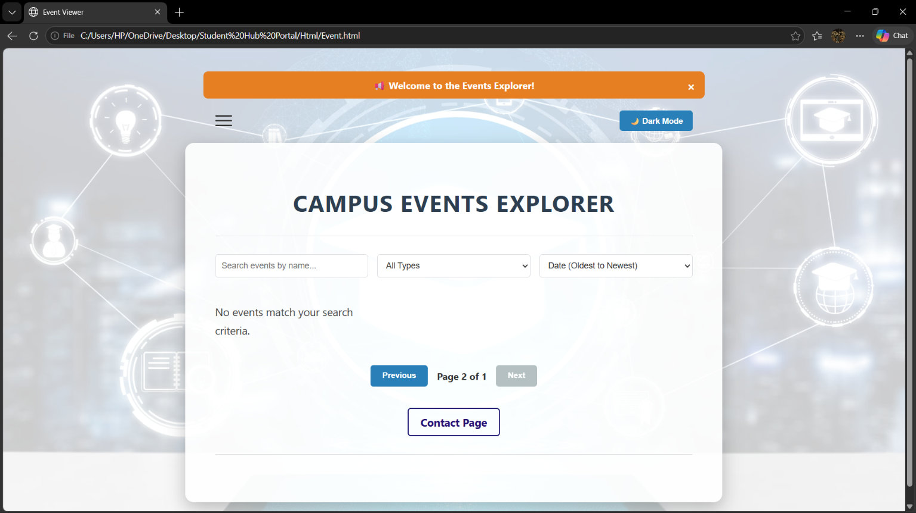

GitHub Repository Link:
https://github.com/RajMonani/Student-Portal-Hub

Challenges Faced:

While doing this practical, I faced some small issues with fetching the JSON file and connecting the JavaScript file correctly. I also had to understand how filtering, sorting, and pagination work together. Fixing these issues helped me understand the Fetch API and JavaScript array methods better.

Learning Outcomes:

This practical helped us understand how to fetch and display JSON data using JavaScript. We also learned to add search, filter, sorting, and pagination features and handle loading and error messages.

Faculty Remarks:

